**Pomodoro clock Requirements Specification**

**Version 1.0**

**April 22, 2016**

**Author: Petroslav Benchovsky**

Table of Contents

1. Executive Summary 3

1.1. Project Overview 3

1.2. Purpose and Scope of this Specification 3

2. Product Description 3

2.1. Product Context 4

2.2. User Characteristics 4

2.3. Assumptions 4

2.4. Dependencies 4

3. Requirements 4

3.1. Hardware Requirements 5

3.2. Functional Requirements 5

3.3. Usability Requirements 7

4. Deleted or Deferred Requirements 7

5. Requirements Confirmation 8

# Executive Summary

## Project Overview

The product that this requirements documents aims to specify is a High-Tech Pomodoro Clock. The clock will be able to calculate and differentiate between focused work spurs and breaks.

This document is intended for technical and non-technical audiences and will contain the specifications of the project. Basic scheme of the finished product can be seen on Fig. 1.

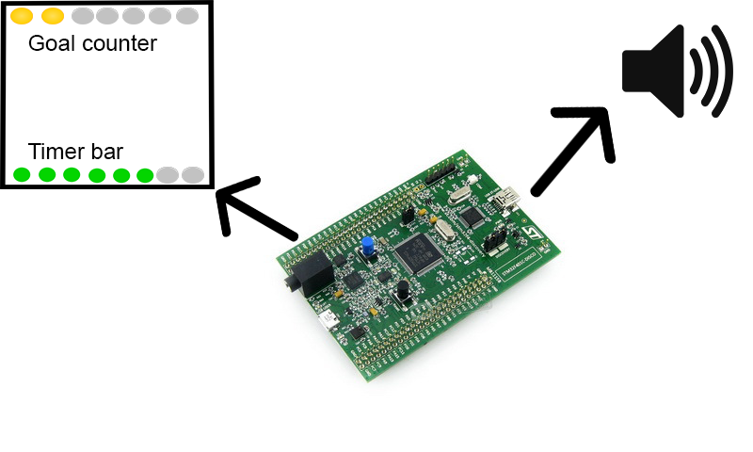

Fig. 1. Basic scheme

## Purpose and Scope of this Specification

The purpose of this specification is to give thorough description of all of the requirements needed for the implementation of the project.

**In scope**

This document addresses requirements related to phase 1 of Pomodoro clock project:

* Creation of fully functioning Pomodoro clock which meets the standards of the client.
* Creation of accessible and user friendly usage of the product based on the needs specified by the client.

# Product Description

This section, describes the general factors that affect the product, the correct delivery of the product and its requirements.

## Product Context

The product is independent and self-contained. It is not required for any other systems to be purchased and implemented for the correct and proper work of the clock.

## User Characteristics

The product is intended for everyday use and the user can be anyone. There are no technical skills required for the proper usage of the product.

## Assumptions

With the delivery of the product the following assumptions were made:

* The client will acquaint all the users with the necessary knowledge to operate the Pomodoro clock. This includes commands for usage and setup of the product in the user’s personal space.
* The client will provide the necessary hardware for the product to operate correctly.

## Dependencies

This new product will require the following hardware to operate correctly:

* STM32 F4 01 Nucleo
* Display (unknown for now)
* Buzzer or Speaker (unknown for now)

# Requirements

**Priority Definitions**

The following definitions are intended as a guideline to prioritize requirements in order for the workflow to be in stages and not at once.

* Priority 1 – The requirement is a “must have”, because without it nothing will function
* Priority 2 – The requirement is needed for basic operations to be enabled in the functionality of the product.
* Priority 3 – The requirement is a final touch in the process of developing the product

**Status Definitions**

The following definitions are intended to follow the process of development for specific requirement.

* Status APPR – The requirement is approved but no work has been yet done
* Status NEW – The requirement is pending approval and is newly added
* Status REJ – The requirement has been rejected

**Glossary**

|  |  |
| --- | --- |
| **Term** | **Definition** |
| chip | Nucleo board – STM32 F4 01 series |
| screen | (unknown – not available yet) |
| buzzer | (unknown – not available yet) |
| console | The console that is used for navigation in the menu and for basic usage of the Pomodoro clock |

## Hardware Requirements

|  |  |  |  |  |  |  |
| --- | --- | --- | --- | --- | --- | --- |
| **Req#** | **Business Requirement** | **Comments** | **Status** | **Pri** | **Date**  **Rvwd** | **Reviewed/**  **Approved** |
| HR _01 | Chip must be connected to buzzer via port (unknown) |  | NEW | 1 | 26/04/16 | Kaloyan Nikolov |
| HR _02 | Buzzer signal shall be 2 seconds long | After each change of state: Work spur or break. | NEW | 2 | 26/04/16 | Kaloyan Nikolov |
| HR _03 | Chip must be connected to screen via port (unknown) |  | NEW | 1 | 26/04/16 | Kaloyan Nikolov |

## Functional Requirements

|  |  |  |  |  |  |  |
| --- | --- | --- | --- | --- | --- | --- |
| **Req#** | **Business Requirement** | **Comments** | **Status** | **Pri** | **Date**  **Rvwd** | **Reviewed/**  **Approved** |
| FR_01 | Welcome page should be created in the console at the start of the application | The text visualized in the console should be as follows: “Welcome to your own personal focus trainer. Press Enter to proceed to the Menu” | NEW | 3 | 26/04/16 | Kaloyan Nikolov |
| FR_02 | After user has pressed the “Enter” key a Menu page should appear in the console. | Every option in the Menu page will be listed as different requirement | NEW | 3 | 26/04/16 | Kaloyan Nikolov |
| FR_03 | Menu page should have option for setting up a clear amount of daily work intervals that the user wants to achieve. | This should be visually represented as text in the Menu page | NEW | 2 | 26/04/16 | Kaloyan Nikolov |
| FR_04 | The total amount of work intervals in hours should not be more than 8 hours. |  | NEW | 2 | 26/04/16 | Kaloyan Nikolov |
| FR_05 | Menu page should have option for starting a work interval |  | NEW | 2 | 26/04/16 | Kaloyan Nikolov |
| FR_06 | Work interval should be 25 minutes long |  | NEW | 2 | 26/04/16 | Kaloyan Nikolov |
| FR_07 | When user starts a work interval there must be a timer that starts the countdown. |  | NEW | 1 | 26/04/16 | Kaloyan Nikolov |
| FR_08 | Timer bar should be implemented on the screen. Green pixels will light up for the time that passes | Timer bar will be used for both work intervals and breaks. For reference how the timer bar should look use Fig. 1. | NEW | 3 | 26/04/16 | Kaloyan Nikolov |
| FR_09 | Goal counter should be implemented on the screen. For every successfully finished work interval a yellow pixel (unknown) lights up. | For reference how the goal counter should look use Fig.1. | NEW | 3 | 26/04/16 | Kaloyan Nikolov |
| FR_10 | Menu page should have option for starting a 5 minutes long break. |  | NEW | 2 | 26/04/16 | Kaloyan Nikolov |
| FR_11 | Menu page should have option for starting a 10 minutes long break. |  | NEW | 2 | 26/04/16 | Kaloyan Nikolov |
| FR_12 | When user is in work mode or in break mode the Menu page must be disabled. |  | NEW | 3 | 26/04/16 | Kaloyan Nikolov |
| FR_13 | When user finishes work mode or break mode the Menu page is enabled and awaits user input. |  | NEW | 3 | 26/04/16 | Kaloyan Nikolov |
| FR_14 | Menu page should have option for exiting the application from the console. | The text of the option should be: “Close the Pomodoro clock!” | NEW | 3 | 26/04/16 | Kaloyan Nikolov |
| FR_15 | Goal counter must have default value of 10 work intervals |  | NEW | 2 | 26/04/16 | Kaloyan Nikolov |

## Usability Requirements

|  |  |  |  |  |  |  |
| --- | --- | --- | --- | --- | --- | --- |
| **Req#** | **Business Requirement** | **Comments** | **Status** | **Pri** | **Date**  **Rvwd** | **Reviewed/**  **Approved** |
| UR_01 | User must navigate through the menu via the numbers of the menu options |  | NEW | 2 | 26/04/16 | Kaloyan Nikolov |
| UR_02 | If the user inputs wrong option a message: “Wrong option! Choose again.” Should be displayed. |  | NEW | 2 | 26/04/16 | Kaloyan Nikolov |

# Deleted or Deferred Requirements

This section will identify any requirements that have been deleted after approval of client and Project Manager or requirements that may be delayed until future versions of the product.

|  |  |  |  |  |  |  |
| --- | --- | --- | --- | --- | --- | --- |
| **Req#** | **Business Requirement** | **Status** | **Comments** | **Pri** | **Date**  **Rvwd** | **Reviewed/**  **Approved** |
| SR_01 | This is sample requirement | April 2016:  Deleted  This requirement has been replaced by  BR_LR_011 and BR_CC_22 | The requirement was not clear enough. The requirement was broken into 2 requirements | 1 | 22/04/16 | Petroslav Benchovsky |

# Requirements Confirmation

Documentation of the approval or confirmation of requirements.

|  |  |  |
| --- | --- | --- |
| **Meeting Date** | **Attendees (name and role)** | **Comments** |
| 22/04/16 | Atanas Grudev, Project Manager  Petroslav Benchovsky, Requirement En.  Kaloyan Nikolov, Architect  Dimitar Bogdanski, Developer  Paolina Panamska, Testing Engineer | Confirmed HR_01 – HR_03 Confirmed FR_01 – FR_15  Confirmed UR_01 – UR_02 |